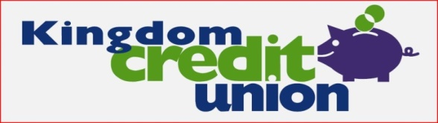
MEMBER ACKNOWLEDGEMENT OF KEY INFORMATON
MEMBER NAME: MEMBERSHIP NO:
Please read the following paragraphs and initial the relevant boxes to acknowledge receipt and understanding.
INITIALS
I understand that Kingdom Credit Union (KCU) is a not-for-profit organization and that any money made above the cost of operations is returned to the members in the form of a dividend.
By joining KCU, I understand that I am opening a KCU share account and that I am becoming a part owner of the Credit Union.
I understand that KCU is governed by a volunteer Board of Directors, elected by and from its membership.
I understand that by joining a Credit Union, I am becoming part of a worldwide movement that promotes thrift, financial independence and co-operation.
I understand that as a part owner of KCU there is a responsibility for me to act in good faith at all time in my dealings with the Credit Union.
I understand that KCU is covered by the Financial Services Compensation Scheme and that it is authorised by the Prudential Regulation Authority and regulated by the Financial Conduct Authority and the Prudential Regulation Authority.
By saving with KCU, I understand that my money stays in the local community – it will therefore be loaned to fellow members of my local community.
By borrowing from KCU, I understand that I am borrowing money deposited by fellow members of my local community.
I understand that KCU is committed to becoming the largest non-profit community based ethical lender in Fife and is committed to helping the financially excluded.
I understand that where it has been agreed that any loan I receive from KCU will be repaid through a benefit or benefits being paid directly to KCU by the Department of Works and Pensions (DWP), KCU will seek security over these loans by requiring me to authorise it to seek redirection of these benefit(s) back to KCU in any event of non-repayment of loans, and that this redirection will be sought until such loans are fully repaid.
Signed:
Date:

